**Problem Statement: -**

You work for XYZ Corporation. Your corporation wants to launch a new web-based application and they do not want their servers to be running all the time. It should also be managed by AWS. Implement suitable solutions.

**Tasks To Be Performed:**

1. Create a sample Python Lambda function.

2. Set the Lambda Trigger as SQS and send a message to test invocations

**Procedure: -**

* Let us first create the Lambda function. Go to the AWS Management Console. Open the Lambda service.
* Click on "Create function."
* Choose "Author from scratch."
* Enter a name for your function, like "MyPythonFunction."
* For Runtime, select "Python" and choose the latest supported version.
* Under "Permissions," you can either choose an existing role with Lambda execution permissions or create a new role with basic Lambda permissions and also the basic permission of cloudWatch and SQS.
* Click on "Create function."

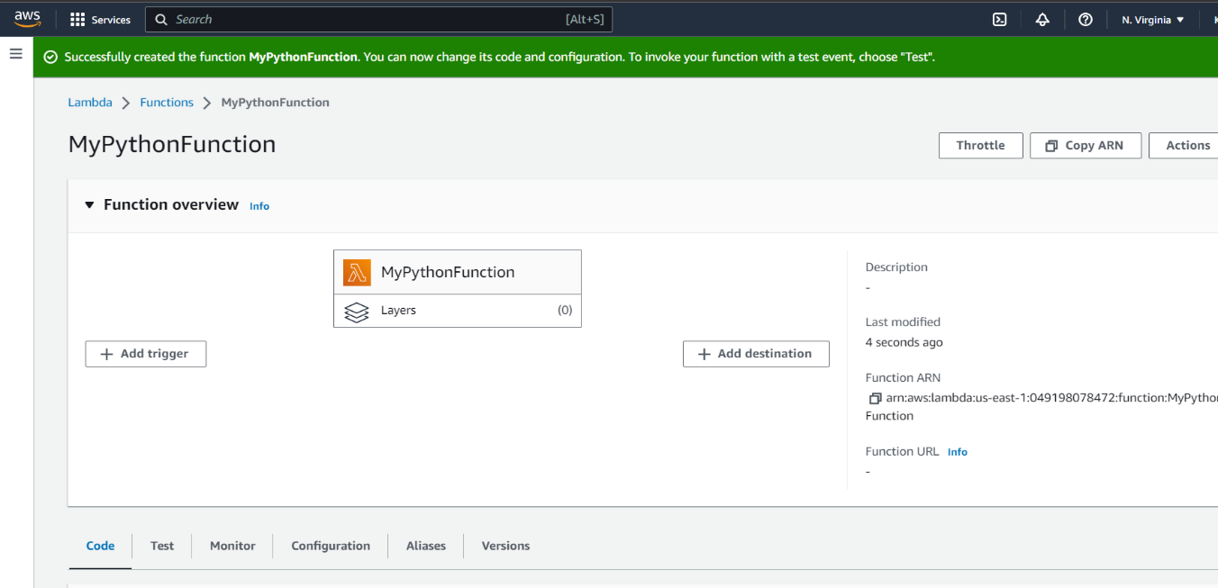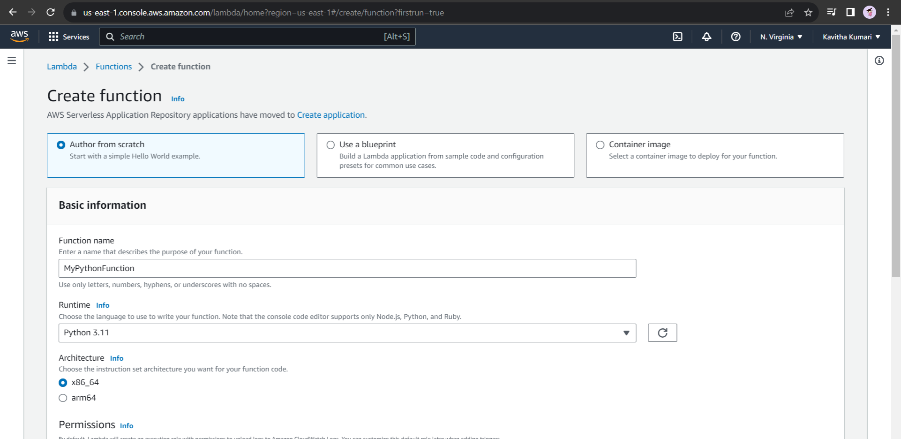

* In the code editor, you can write a simple Python function, such as:

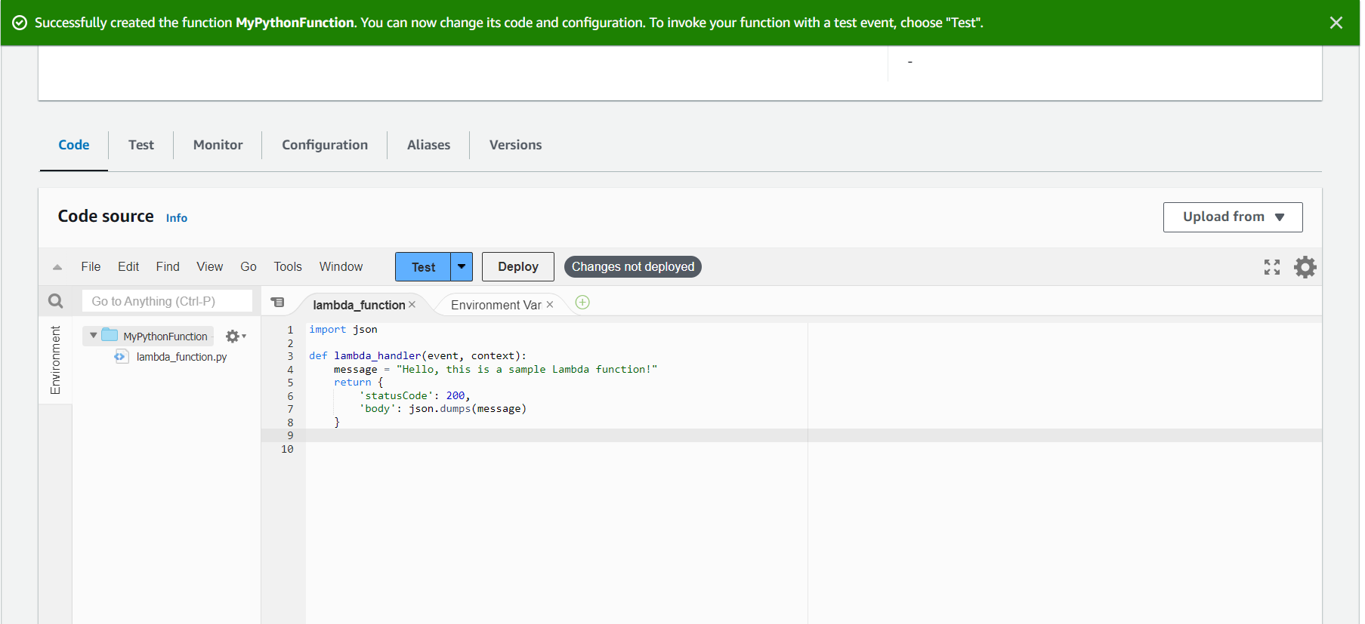

* Click on “deploy.”
* Now we need to Set up the Lambda Trigger as SQS.
* For this let us create an SQS service.
* Click on "create queue."
* Enter a name for your queue, like "MyQPython."
* Leave other settings as default and click on "Create queue."

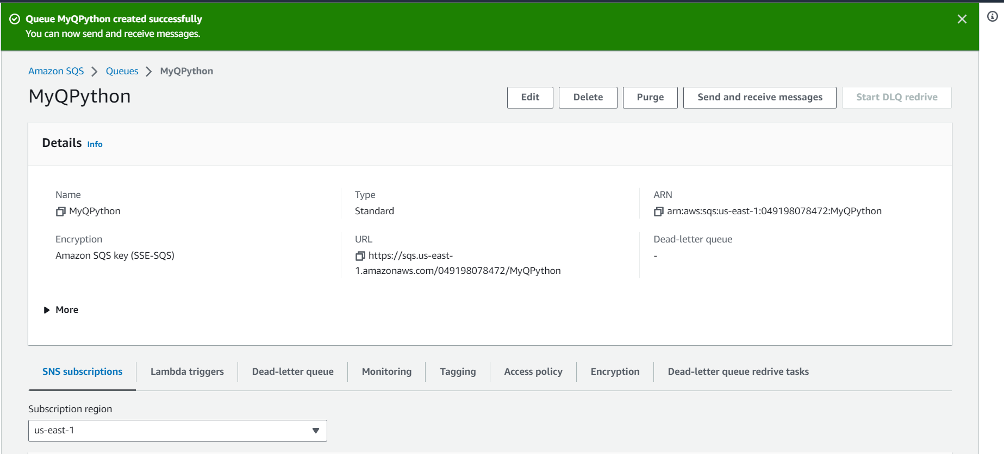

* Next, we need to set up the SQS trigger for our Lambda function:
* Go back to the Lambda service.
* Open your Lambda function (MyPythonFunction) that you created earlier.
* In the function configuration page, click on "Add trigger."
* Choose "SQS" as the trigger type.
* From the "Queue" dropdown, select the SQS queue you created earlier (MyQPython).
* Leave other settings as default, and click on "Add."

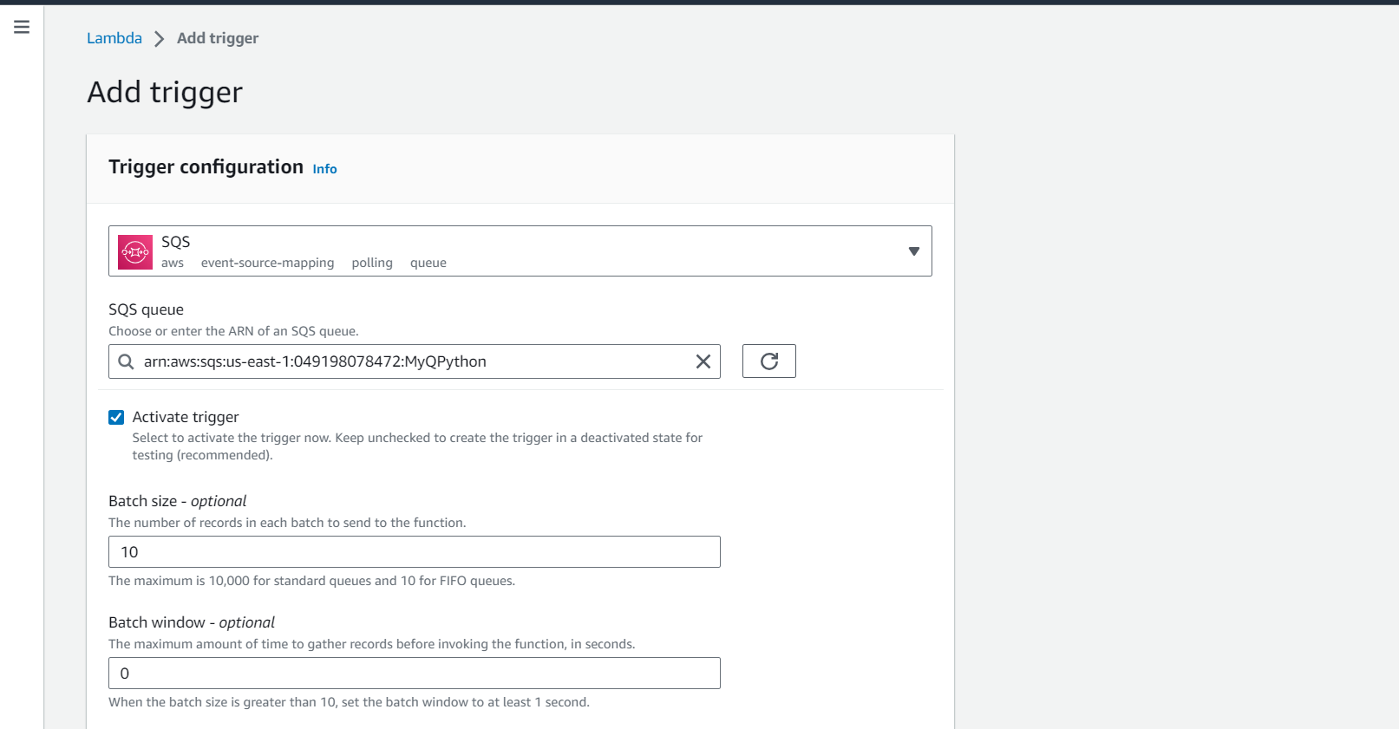

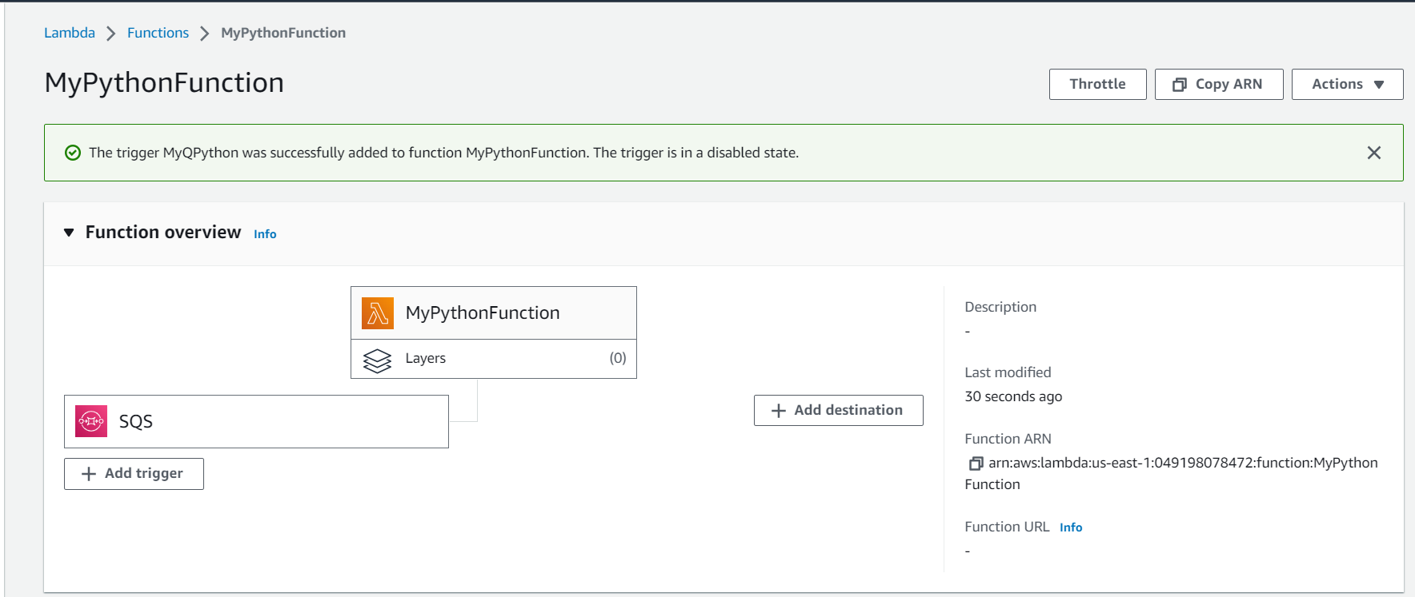

* Now, when a message is sent to the SQS queue (MyQPython), it will trigger the Lambda function (MyPythonFunction) and invoke it.
* Go to the AWS Management Console.
* Open the Amazon SQS service.
* Select your SQS queue (MyQpython) from the list.
* Click on "Send and receive messages" and then "Send a message."
* In the message body, you can enter any test message (e.g., "Test message for Lambda").
* Click on "Send message."
* After a moment, the Lambda function will be triggered and will process the message. You can check the function's logs in the AWS Lambda console to see the output.
* That is, it! You have successfully created a sample Python Lambda function and set up an SQS trigger to invoke it when messages are sent to the SQS queue.

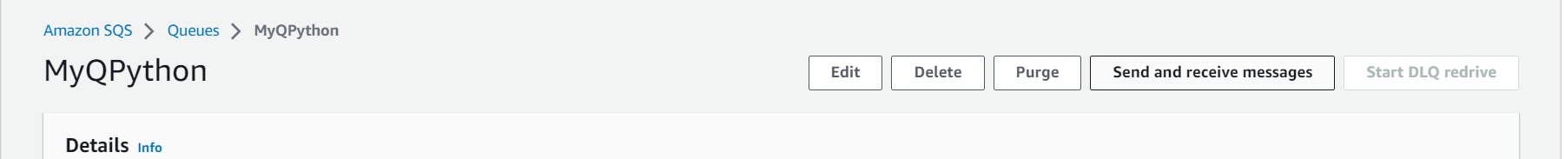

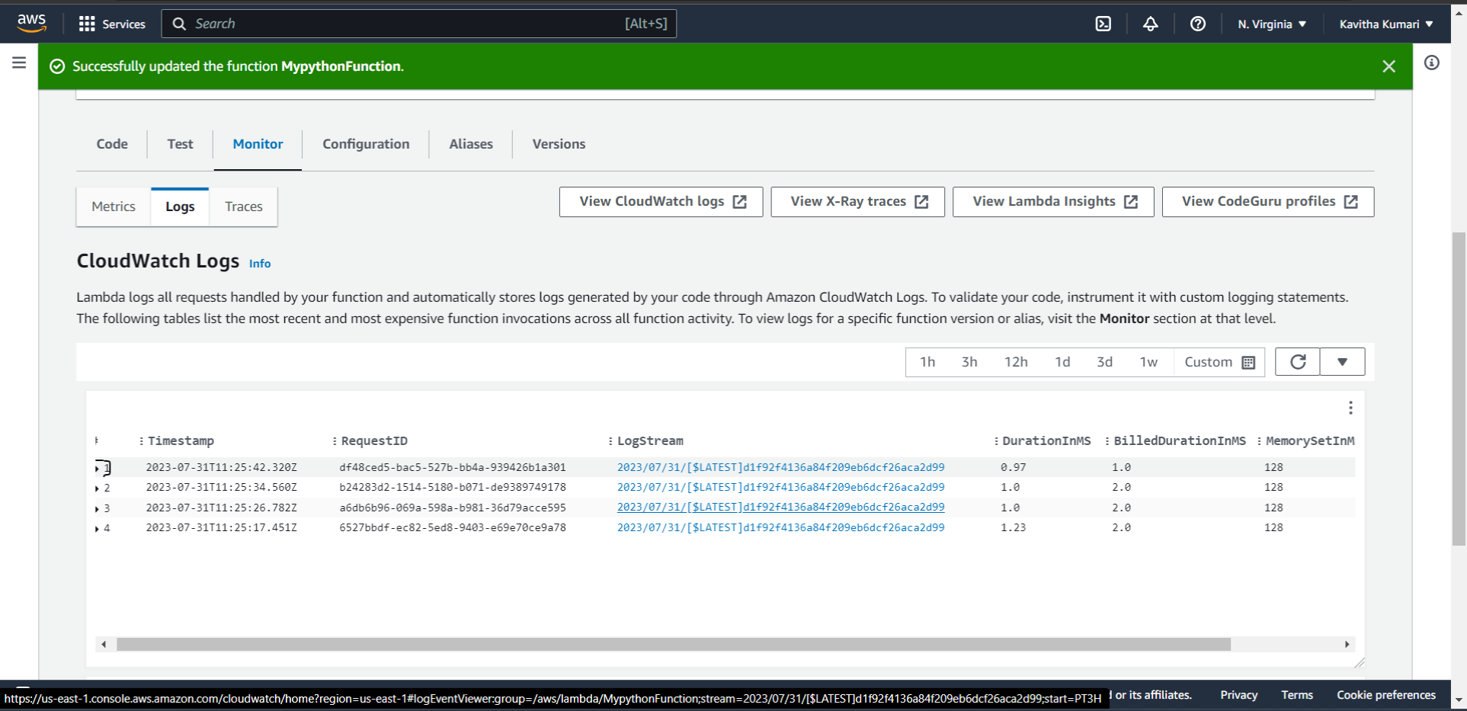

* You can also click on **view CloudWatch logs** to view the detailed information.

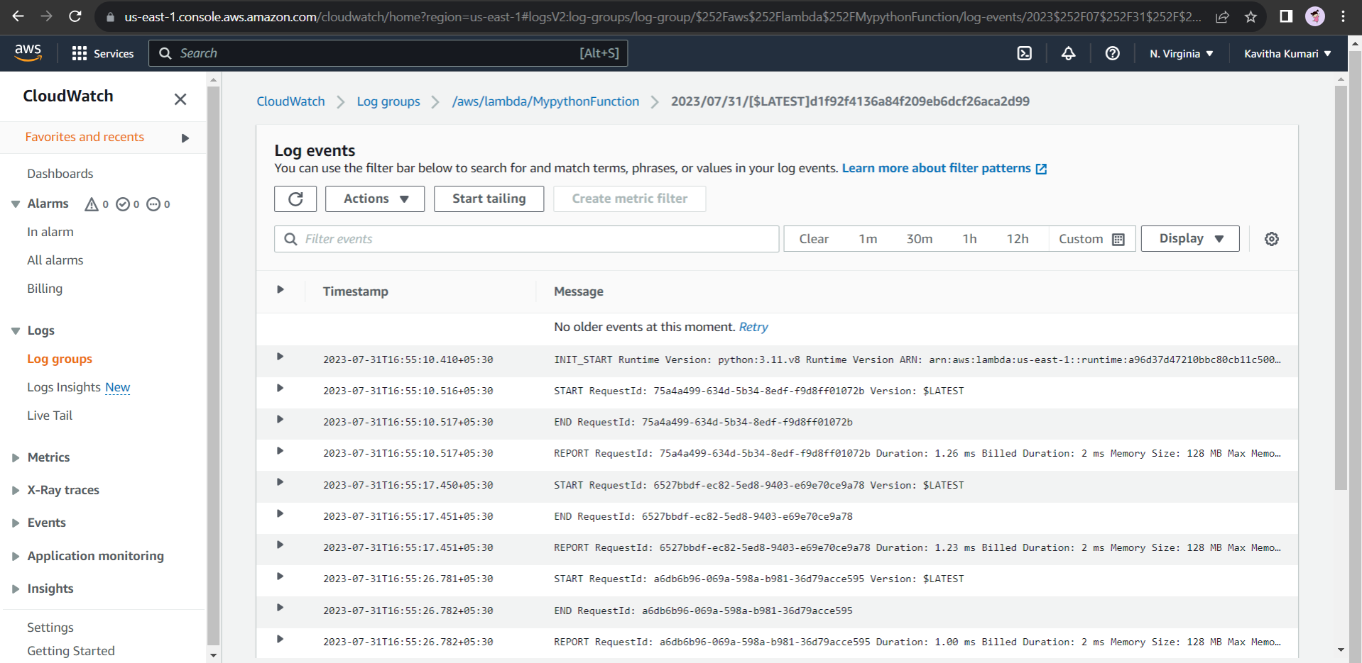

-------END--------